Garbage collector:-

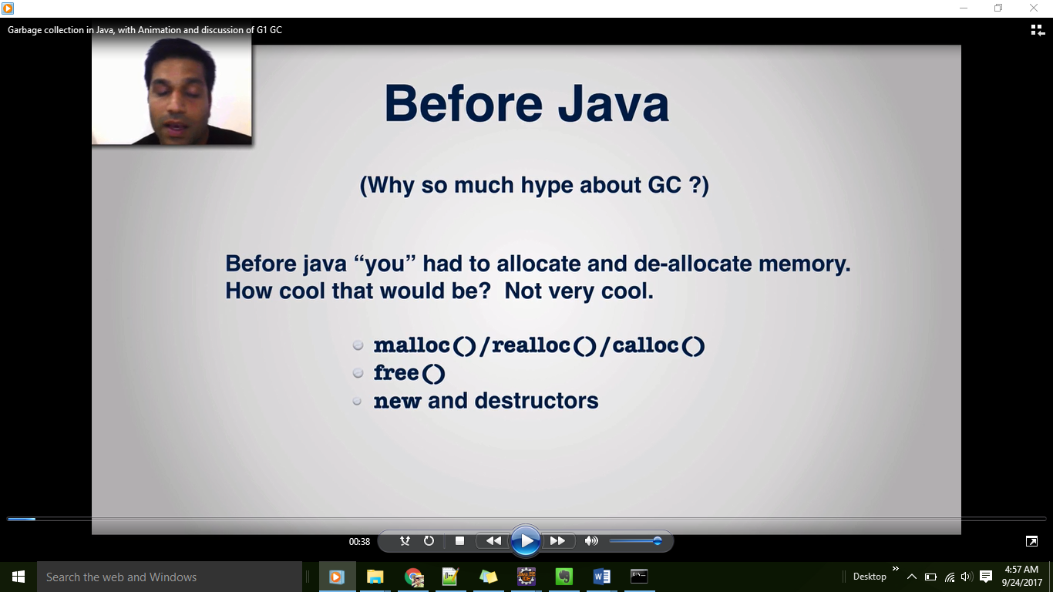

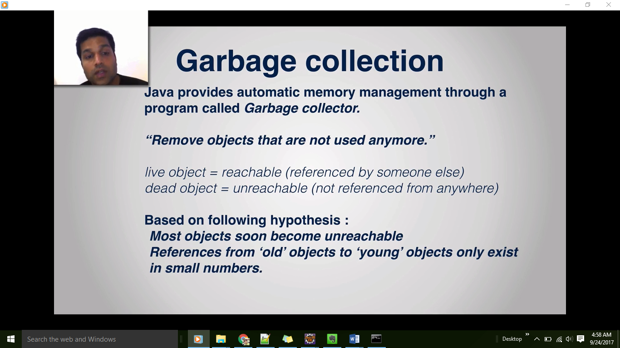

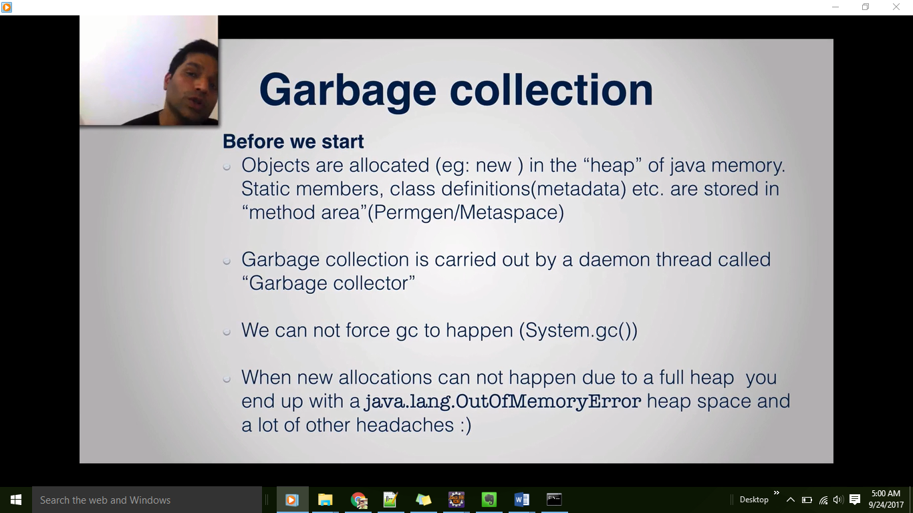

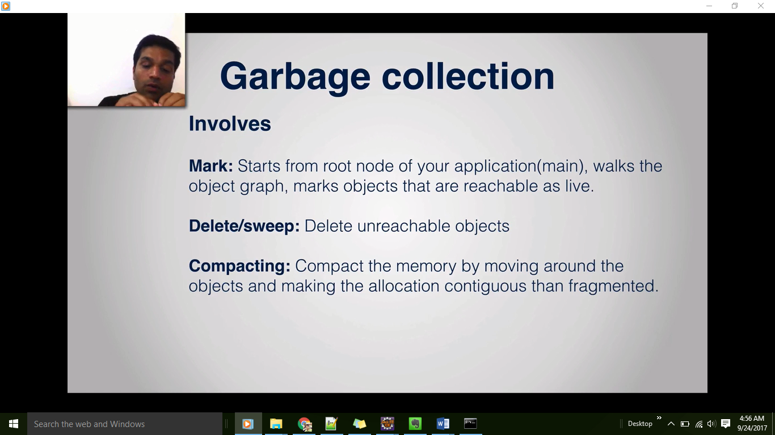

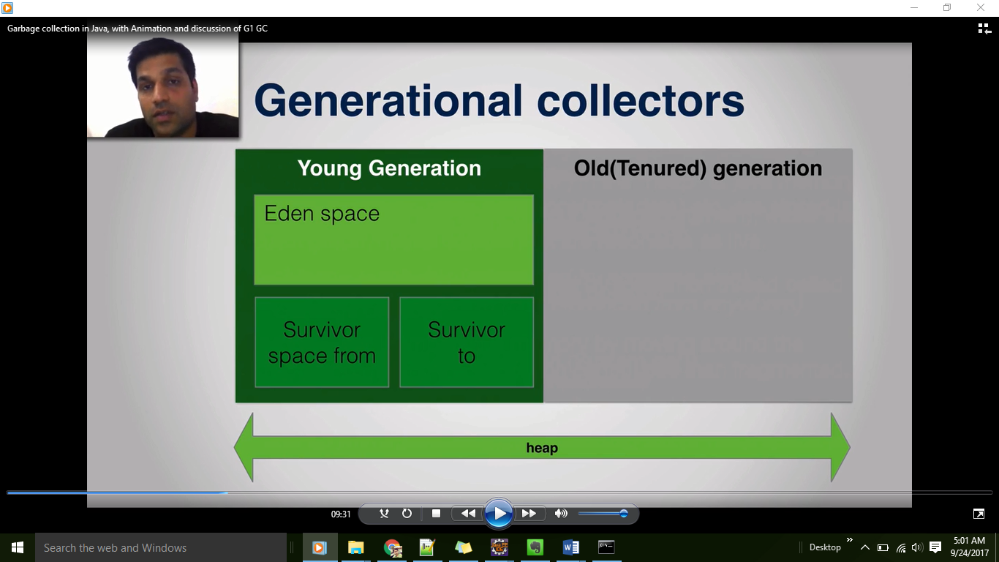

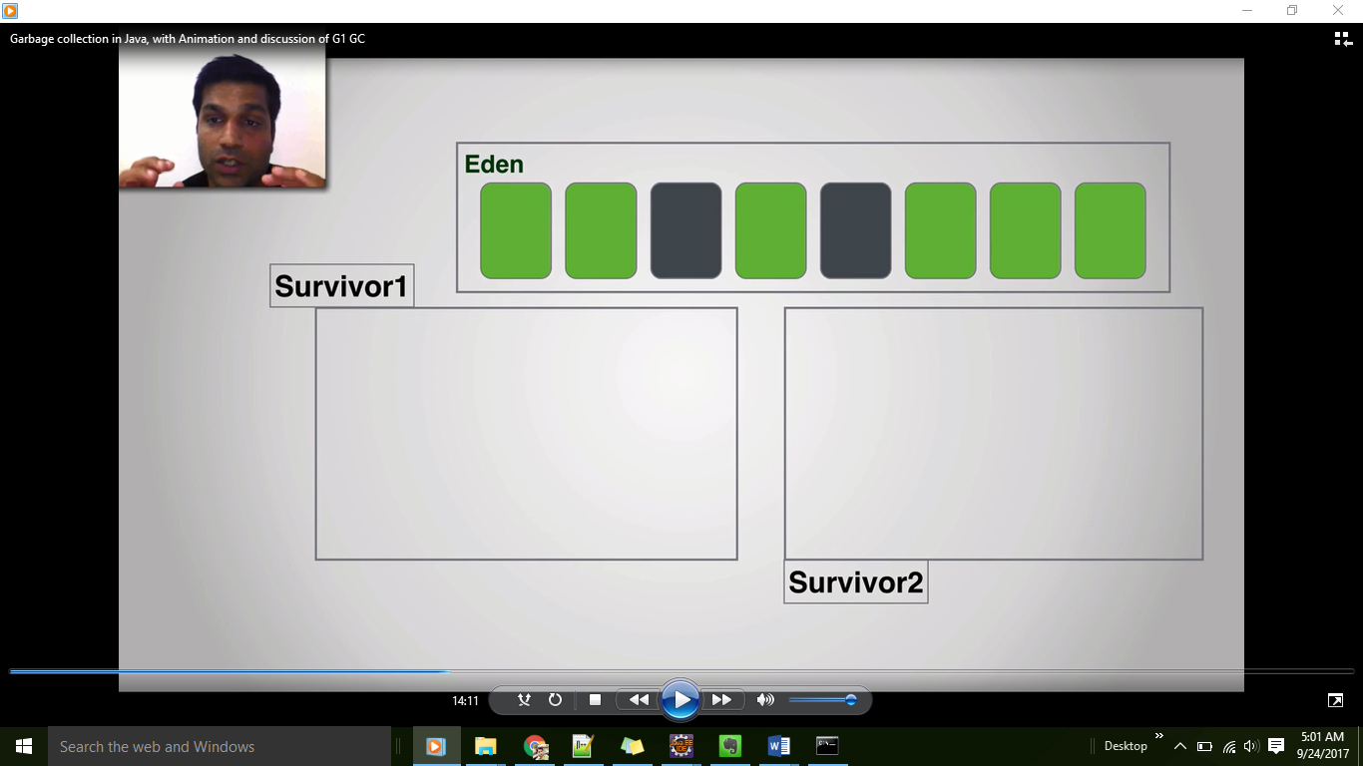

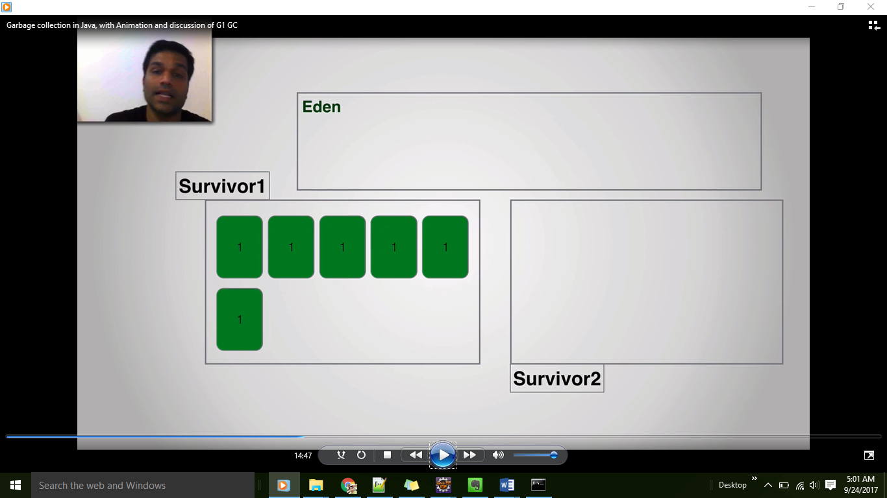

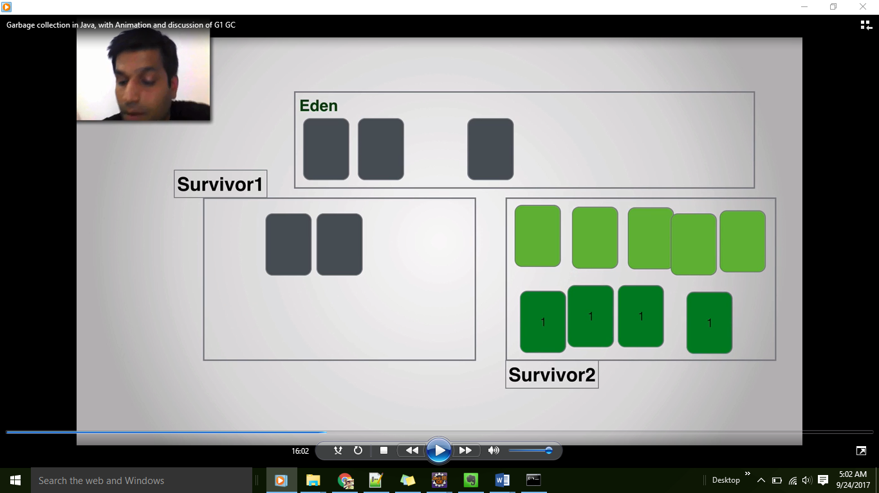

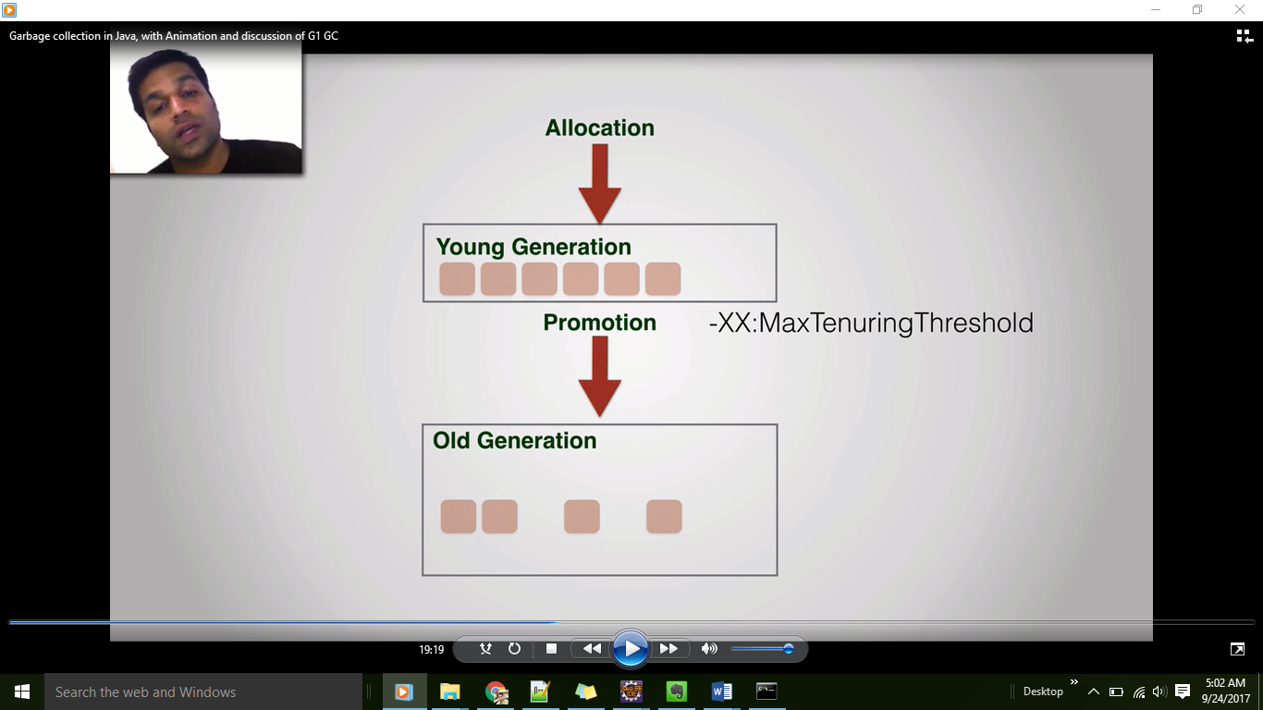

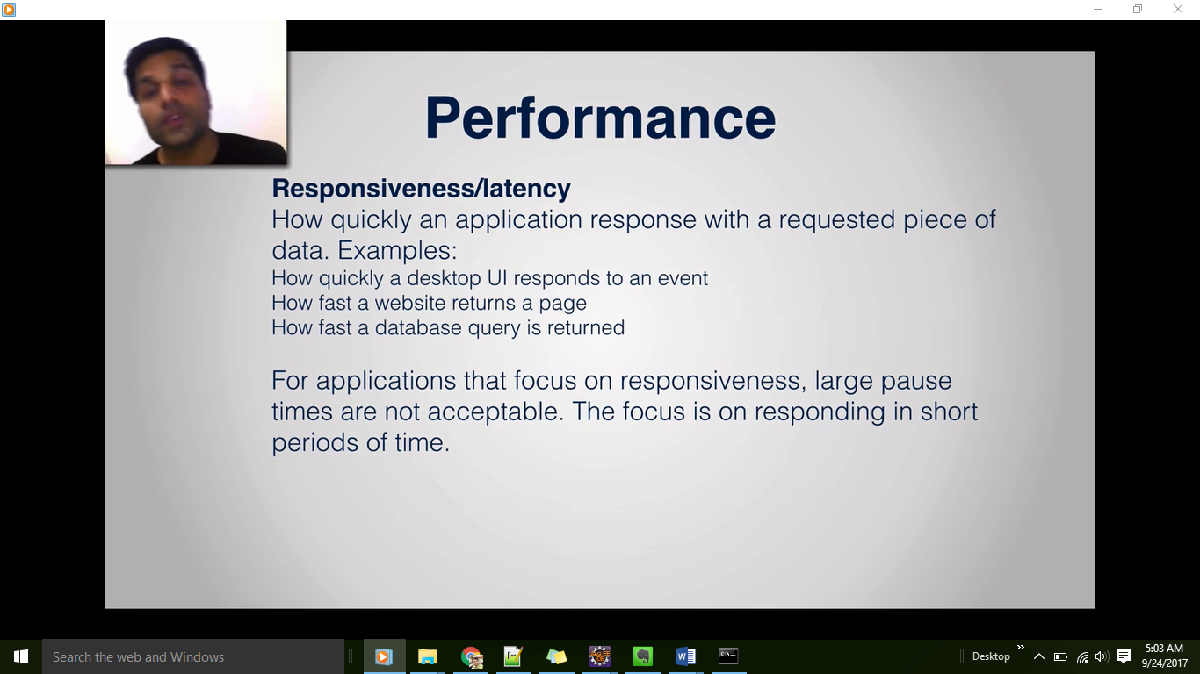

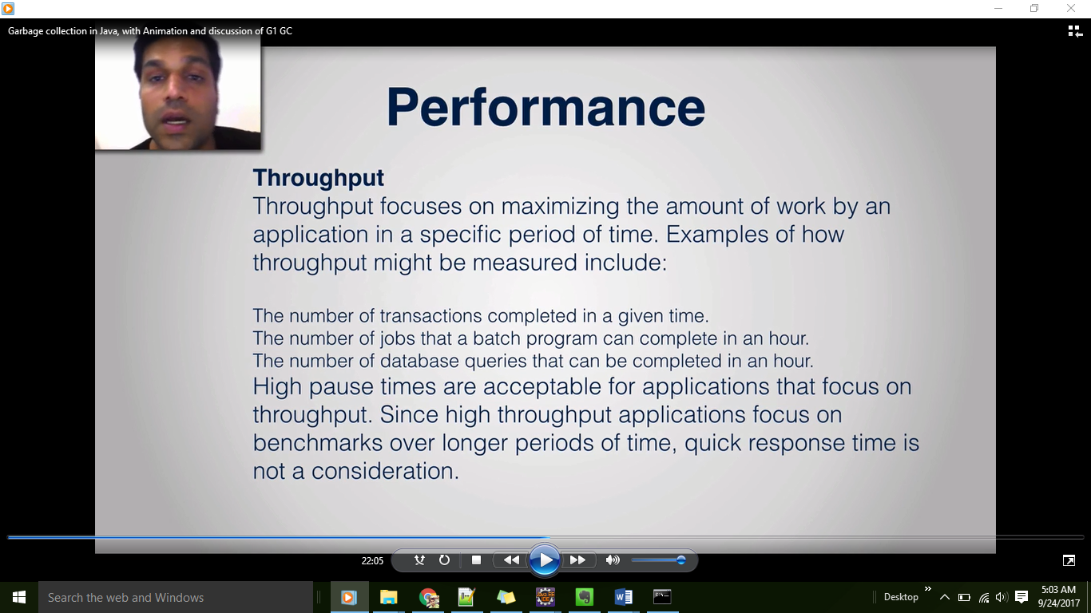

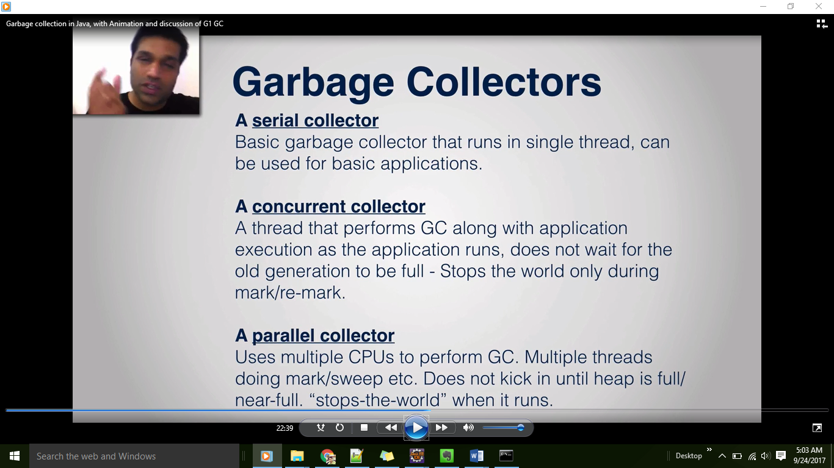

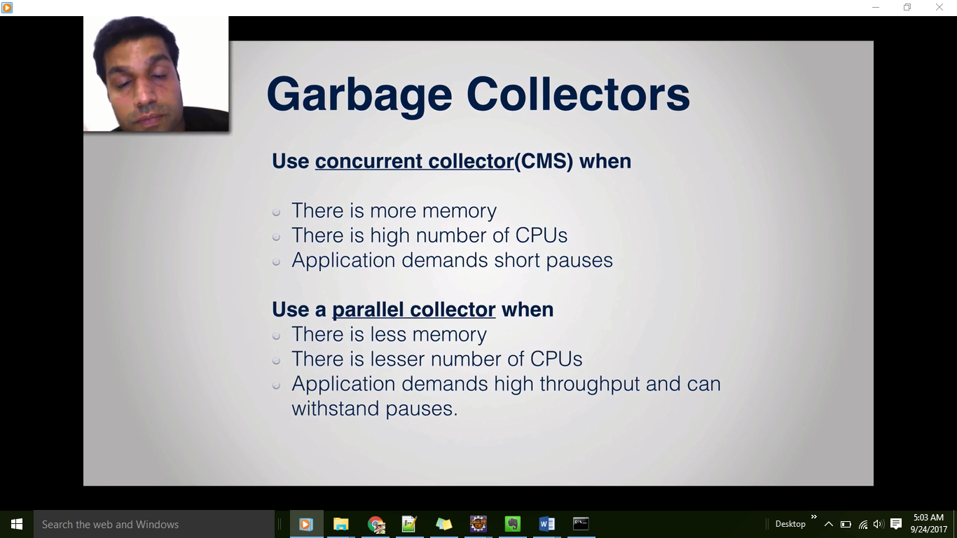

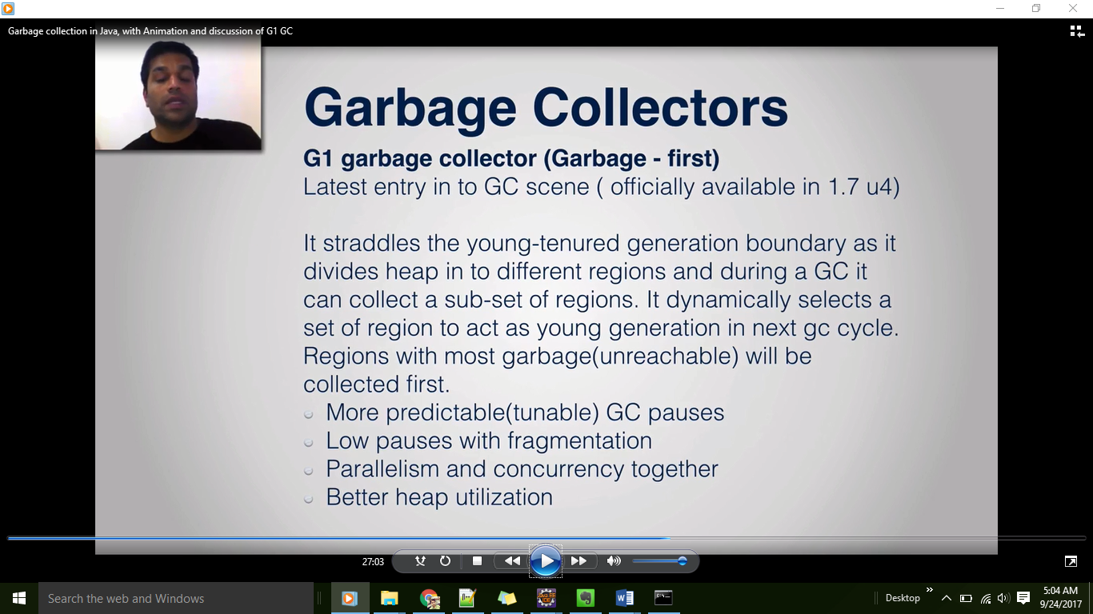

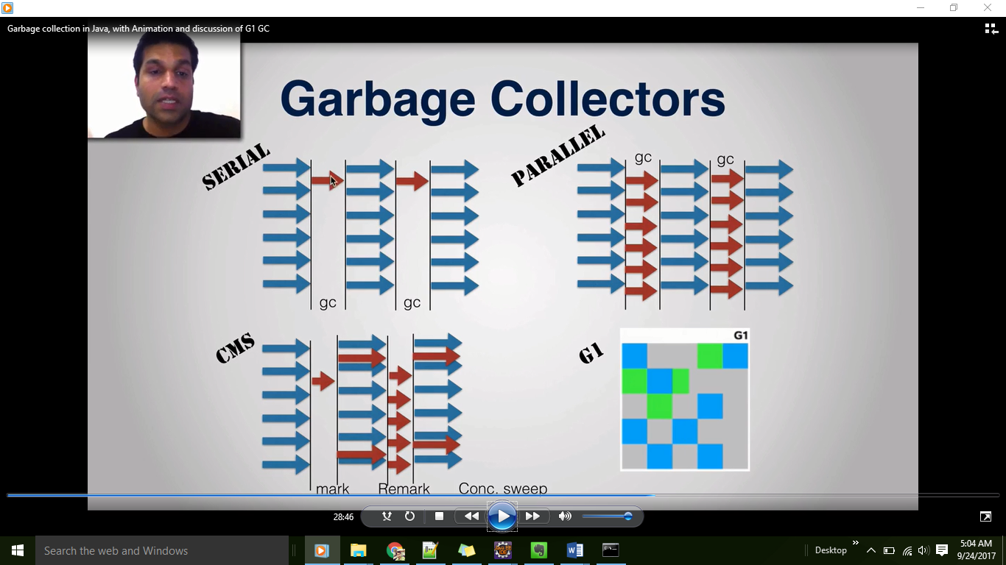

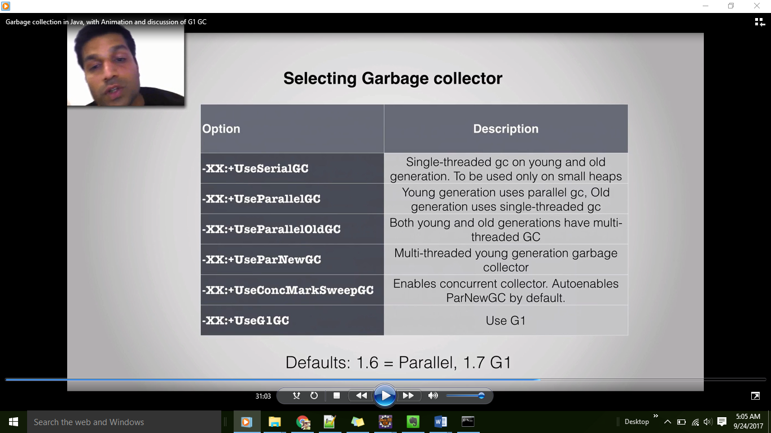

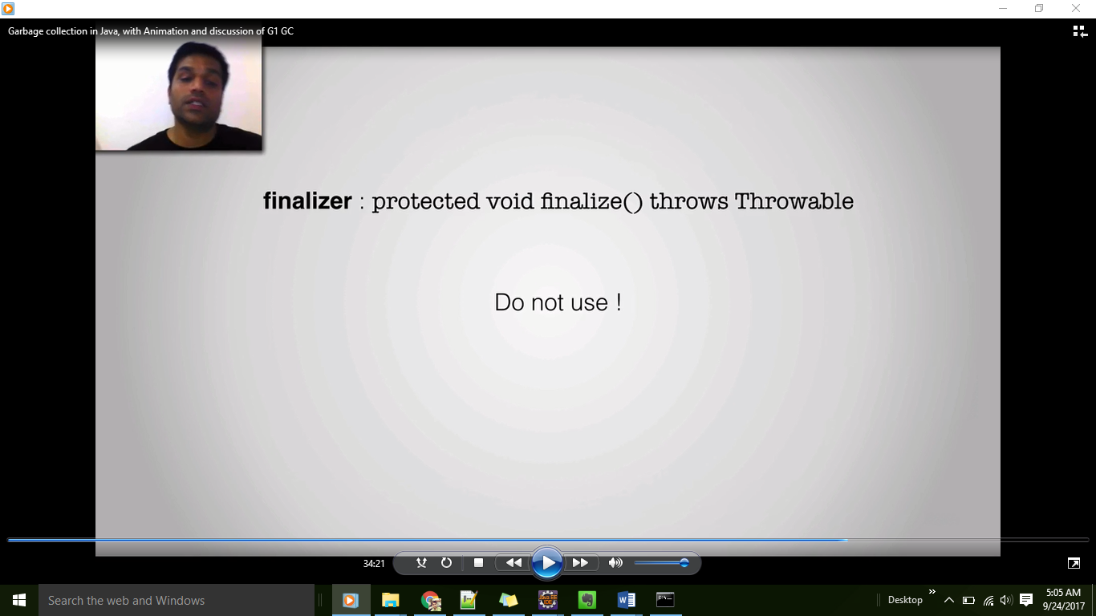

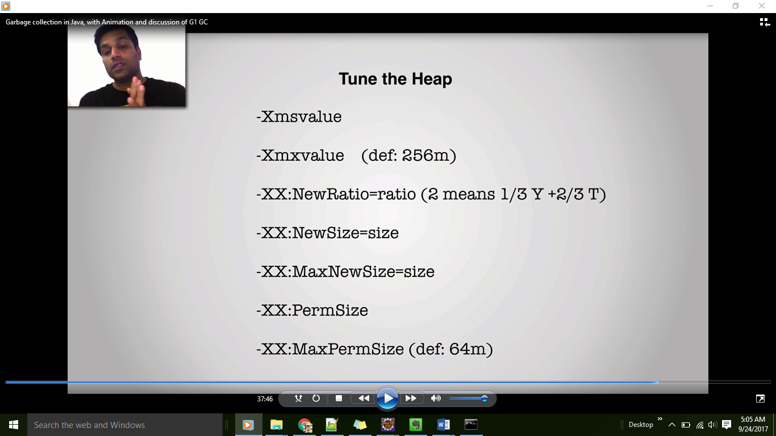

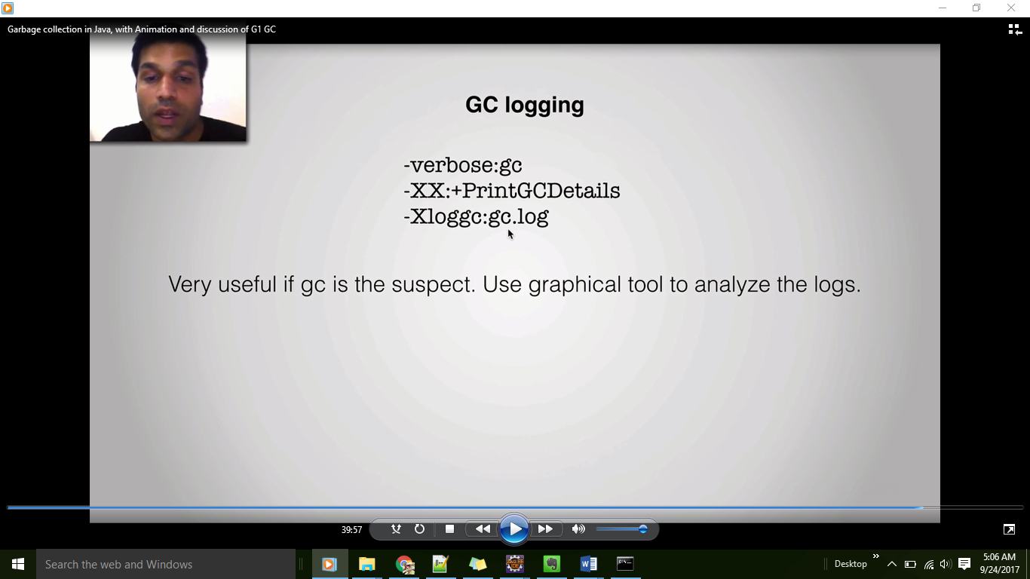



Garbage Collection in Java

**Introduction**

* In C/C++, programmer is responsible for both creation and destruction of objects. Usually programmer neglects destruction of useless objects. Due to this negligence, at certain point, for creation of new objects, sufficient memory may not be available and entire program will terminate abnormally causing **OutOfMemoryErrors**.
* But in Java, the programmer need not to care for all those objects which are no longer in use. Garbage collector destroys these objects.
* Garbage collector is best example of [Daemon thread](http://www.geeksforgeeks.org/daemon-thread-java/) as it is always running in background.
* Main objective of Garbage Collector is to free heap memory by destroying **unreachable objects**.

**Important terms :**

1. **Unreachable objects :**An object is said to be unreachable iff it doesn’t contain any reference to it. Also note that objects which are part of [island of isolation](http://www.geeksforgeeks.org/island-of-isolation-in-java/) are also unreachable.
2. Integer i = new Integer(4);
3. // the new Integer object is reachable via the reference in 'i'
4. i = null;
5. // the Integer object is no longer reachable.

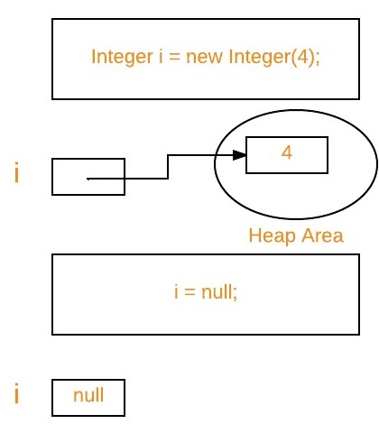

1. **Eligibility for garbage collection :**An object is said to be eligible for GC(garbage collection) iff it is unreachable. In above image, after *i = null;* integer object 4 in heap area is eligible for garbage collection.

**Ways to make an object eligible for GC**

* Even though programmer is not responsible to destroy useless objects but it is highly recommended to make an object unreachable(thus eligible for GC) if it is no longer required.
* There are generally four different ways to make an object eligible for garbage collection.
  + 1. Nullifying the reference variable
    2. Re-assigning the reference variable
    3. Object created inside method
    4. [Island of Isolation](http://www.geeksforgeeks.org/island-of-isolation-in-java/)

All above ways with examples are discussed in separate article : [How to make object eligible for garbage collection](http://www.geeksforgeeks.org/how-to-make-object-eligible-for-garbage-collection/)

**Ways for requesting**[**JVM**](http://www.geeksforgeeks.org/jvm-works-jvm-architecture/)**to run Garbage Collector**

* Once we made object eligible for garbage collection, it may not destroy immediately by garbage collector. Whenever JVM runs Garbage Collector program, then only object will be destroyed. But when JVM runs Garbage Collector, we can not expect.
* We can also request JVM to run Garbage Collector. There are two ways to do it :
  + 1. **Using *System.gc()* method** : System class contain static method *gc()* for requesting JVM to run Garbage Collector.
    2. **Using *Runtime.getRuntime().gc()* method** : [Runtime class](http://www.geeksforgeeks.org/java-lang-runtime-class-in-java/) allows the application to interface with the JVM in which the application is running. Hence by using its gc() method, we can request JVM to run Garbage Collector.

|  |
| --- |
| // Java program to demonstrate requesting  // JVM to run Garbage Collector  public class Test  {      public static void main(String[] args) throws InterruptedException      {          Test t1 = new Test();          Test t2 = new Test();            // Nullifying the reference variable          t1 = null;            // requesting JVM for running Garbage Collector          System.gc();            // Nullifying the reference variable          t2 = null;            // requesting JVM for running Garbage Collector          Runtime.getRuntime().gc();        }        @Override      // finalize method is called on object once      // before garbage collecting it      protected void finalize() throws Throwable      {          System.out.println("Garbage collector called");          System.out.println("Object garbage collected : " + this);      }  } |

* Run on IDE
* Output:
* Garbage collector called
* Object garbage collected : Test@46d08f12
* Garbage collector called
* Object garbage collected : Test@481779b8
* **Note :**
  + 1. There is no guarantee that any one of above two methods will definitely run Garbage Collector.
    2. The call *System.gc()* is effectively equivalent to the call : *Runtime.getRuntime().gc()*

**Finalization**

* Just before destroying an object, Garbage Collector calls *finalize()* method on the object to perform cleanup activities. Once *finalize()* method completes, Garbage Collector destroys that object.
* *finalize()* method is present in [Object class](http://www.geeksforgeeks.org/object-class-in-java/) with following prototype.
* protected void finalize() throws Throwable

Based on our requirement, we can override *finalize()* method for perform our cleanup activities like closing connection from database.

**Note :**

* 1. The *finalize()*method called by Garbage Collector not [JVM](http://www.geeksforgeeks.org/jvm-works-jvm-architecture/). Although Garbage Collector is one of the module of JVM.
  2. [Object class](http://www.geeksforgeeks.org/object-class-in-java/) *finalize()* method has empty implementation, thus it is recommended to override *finalize()* method to dispose of system resources or to perform other cleanup.
  3. The *finalize()*method is never invoked more than once for any given object.
  4. If an uncaught exception is thrown by the *finalize()* method, the exception is ignored and finalization of that object terminates.

For examples on *finalize()* method, please see [Output of Java programs | Set 10 (Garbage Collection)](http://www.geeksforgeeks.org/output-of-java-programs-set-10-garbage-collection/)

**Ways to make an object eligible for garbage collection:**

*Please note that the object can not become a candidate for garbage collection until all references to it are discarded.*

1. **Object created inside a method :** When a method is called it goes inside the stack frame. When the method is popped from the stack, all its members dies and if some objects were created inside it then these objects becomes unreachable or anonymous after method execution and thus becomes eligible for garbage collection  
   .Example:

|  |
| --- |
| /* Java program to demonstrate that  objects created inside a method will becomes  eligible for gc after method execution terminate */    class Test  {        // to store object name      String obj_name;        public Test(String obj_name)      {          this.obj_name = obj_name;      }        static void show()      {          //object t1 inside method becomes unreachable when show() removed          Test t1 = new Test("t1");          display();        }      static void display()      {          //object t2 inside method becomes unreachable when display() removed          Test t2 = new Test("t2");      }        // Driver method      public static void main(String args[])      {          // calling show()          show();            // calling garbage collector          System.gc();      }        @Override      /* Overriding finalize method to check which object      is garbage collected */      protected void finalize() throws Throwable      {          // will print name of object          System.out.println(this.obj_name + " successfully garbage collected");      }  } |

1. Run on IDE
2. Output:
3. t1 successfully garbage collected
4. t2 successfully garbage collected
5. **Note :** If a method returns the object created inside it and we store this object reference by using a reference-type variable than it is no longer eligible for garbage collection.
6. **Reassigning the reference variable:**When reference id of one object is referenced to reference id of some other object then the previous object has no any longer reference to it and becomes unreachable and thus becomes eligible for garbage collection.Example:

|  |
| --- |
| /* Java program to demonstrate gc   when one object referred to other object */    class Test  {      // to store object name      String obj_name;        public Test(String obj_name)      {          this.obj_name = obj_name;      }        // Driver method      public static void main(String args[])      {          Test t1 = new Test("t1");          Test t2 = new Test("t2");            //t1 now referred to t2          t1 = t2;            // calling garbage collector          System.gc();      }        @Override      /* Overriding finalize method to check which object       is garbage collected */      protected void finalize() throws Throwable      {          // will print name of object          System.out.println(this.obj_name + " successfully garbage collected");      }  } |

1. Run on IDE
2. Output:
3. t1 successfully garbage collected
4. **Nullifying the reference variable :**When all the reference variables of an object are changed to NULL, it becomes unreachable and thus becomes eligible for garbage collection.Example:

|  |
| --- |
| /* Java program to demonstrate gc   when object reference changed to NULL */    class Test  {      // to store object name      String obj_name;        public Test(String obj_name)      {          this.obj_name = obj_name;      }        // Driver method      public static void main(String args[])      {          Test t1 = new Test("t1");            /* t1 being used for some purpose in program */            /* When there is no more use of t1, make the object             referred by t1 eligible for garbage collection */          t1 = null;            // calling garbage collector          System.gc();      }        @Override      /* Overriding finalize method to check which object       is garbage collected */      protected void finalize() throws Throwable      {          // will print name of object          System.out.println(this.obj_name + " successfully garbage collected");      }  } |

1. Run on IDE
2. Output:
3. t1 successfully garbage collected
4. **Anonymous object :**The reference id of an anonymous object is not stored anywhere. Hence, it becomes unreachable.  
   Example:

|  |
| --- |
| /* Java program to demonstrate gc   of anonymous objects */    class Test  {      // to store object name      String obj_name;        public Test(String obj_name)      {          this.obj_name = obj_name;      }        // Driver method      public static void main(String args[])      {          //anonymous object without reference id          new Test("t1");            // calling garbage collector          System.gc();      }        @Override      /* Overriding finalize method to check which object       is garbage collected */      protected void finalize() throws Throwable      {          // will print name of object          System.out.println(this.obj_name + " successfully garbage collected");      }  } |

1. Run on IDE
2. Output:
3. t1 successfully garbage collected

|  |
| --- |
| 1. public class Test 2. { 3. public static void main(String[] args) throws InterruptedException 4. { 5. Test t = new Test(); 7. // making t eligible for garbage collection 8. t = null; 10. // calling garbage collector 11. System.gc(); 13. // waiting for gc to complete 14. Thread.sleep(1000); 16. System.out.println("end main"); 17. } 19. @Override 20. protected void finalize() 21. { 22. System.out.println("finalize method called"); 23. System.out.println(10/0); 24. } 26. } |

Run on IDE

Output:

finalize method called

end main

**Explanation :**  
When Garbage Collector calls finalize() method on an object, it **ignores** all the exceptions raised in the method and program will terminate normally.

**Program 3 :**

|  |
| --- |
| public class Test  {      static Test t ;        static int count =0;        public static void main(String[] args) throws InterruptedException      {          Test t1 = new Test();            // making t1 eligible for garbage collection          t1 = null; // line 12            // calling garbage collector          System.gc(); // line 15            // waiting for gc to complete          Thread.sleep(1000);            // making t eligible for garbage collection,          t = null; // line 21            // calling garbage collector          System.gc(); // line 24            // waiting for gc to complete          Thread.sleep(1000);            System.out.println("finalize method called "+count+" times");        }        @Override      protected void finalize()      {          count++;            t = this; // line 38        }    } |

Run on IDE

**Output:**

finalize method called 1 times

**Explanation :**  
After execution of line 12, t1 becomes eligible for garbage collection. So when we call garbage collector at line 15, Garbage Collector will call finalize() method on t1 before destroying it. But in finalize method, in line 38, we are again referencing the same object by t, so after execution of line 38,[this](http://quiz.geeksforgeeks.org/this-reference-in-java/) object is no longer eligible for garbage collection. Hence, Garbage Collector will not destroy the object.

Now again in line 21, we are making same object eligible for garbage collection one more time. Here, we have to clear about one fact about Garbage Collector i.e. it will call finalize() method on a particular object exactly **one** time. Since on this object, finalize() method is already called, so now Garbage Collector will destroy it without calling finalize() method again.

**Program 4 :**

|  |
| --- |
| public class Test  {      public static void main(String[] args)      {          // How many objects are eligible for          // garbage collection after this line?          m1();  // Line 5      }        static void m1()      {          Test t1 = new Test();          Test t2 = new Test();      }  } |

Run on IDE

**Question :**  
How many objects are eligible for garbage collection after execution of line 5 ?  
**Answer :**

2

**Explanation :**  
Since t1 and t2 are local objects of m1() method, so they become eligible for garbage collection after complete execution of method unless any of them is returned.

**Program 5 :**

|  |
| --- |
| public class Test  {      public static void main(String [] args)      {          Test t1 = new Test();          Test t2 = m1(t1); // line 6          Test t3 = new Test();          t2 = t3; // line 8        }        static Test m1(Test temp)      {          temp = new Test();          return temp;      }  } |

Run on IDE

**Question :**  
How many objects are eligible for garbage collection after execution of line 8?  
**Answer :**

1

**Explanation :**  
By the time line 8 has executed, the only object without a reference is the one generated i.e as a result of line 6. Remember that “[Java is strictly pass by value](http://www.geeksforgeeks.org/passing-and-returning-objects-in-java/)” so the reference variable t1 is not affected by the m1() method. We can check it using finalize() method. The statement “System.out.println(this.hashcode())” in finalize() method print the object hashcode value on which finalize() method is called,and then just compare the value with other objects hashcode values created in main method.